Short Information on Particular Technologies:

*Will need a short lead-in before the information texts, such as*: We will now provide you with some background information on a few technologies. In the remainder of the survey, we want to get your feedback on these technologies, so please read the texts carefully. To make sure you have understood them, the next slide will have one or two short questions to check your comprehension. In order that you do not feel the need to rush, you will only be able to click to the next slide after 60 seconds have passed.

*Group 1 (SRM)*

*Stratospheric Aerosol Injection* – Stratospheric aerosol injection aims to limit the effects of climate change by using planes or balloons to spray small particles of substances (aerosols) into the upper atmosphere. Sulfur dioxide is one example of a substance we could use. The particles would reflect sunlight back into space. This could cool temperatures on Earth. But for this idea to work, we would have to keep doing it continuously. If we stopped, temperatures would rise once again, and probably very quickly, Also, stratospheric aerosol injection would not do anything to reduce our greenhouse gas emissions or help with other impacts, such as ocean acidification.

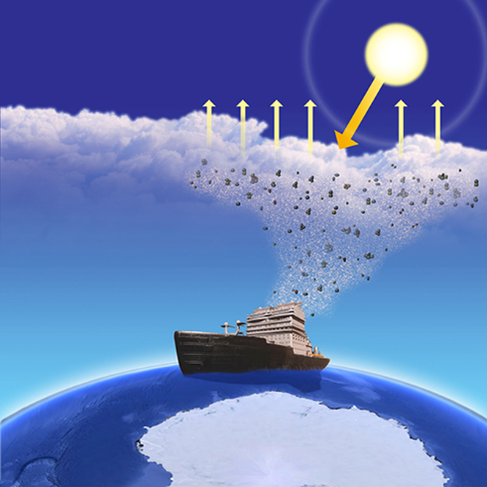*Marine Cloud Brightening* – Marine cloud brightening aims to limit the effects of climate change by spraying small particles of substances, such as sea salt, into the air over the oceans, to make clouds brighter. These clouds would reflect sunlight away from the Earth, which could cool temperatures on a local or regional level. Marine cloud brightening might also help to protect ecosystems threatened by climate change. One way to spray the particles would be to use a fleet of ships. But for this idea to work, we would have to keep doing it continuously. If we stopped, temperatures would rise once again, and probably very quickly. Also, marine cloud brightening would not do anything to reduce our greenhouse gas emissions or help with other impacts, such as ocean acidification.

*Space-based Geoengineering* – Space-based geoengineering aims to limit the effects of climate change by putting a giant mirror or other reflective material in outer space between the Earth and the sun. Such a space mirror or sunshield would deflect sunlight back into space. This could cool temperatures on Earth. Space-based geoengineering also would avoid direct changes to the land, oceans, or atmosphere of the Earth itself. But for this idea to work, we would need to be able to build and maintain something in space much larger than ever before. A space mirror would also be very costly to build, given that its location would be about four times as far from the Earth as the Moon. Also, it would not do anything to reduce our greenhouse gas emissions or help with other impacts, such as ocean acidification.

*Group 2 (CDR1)*

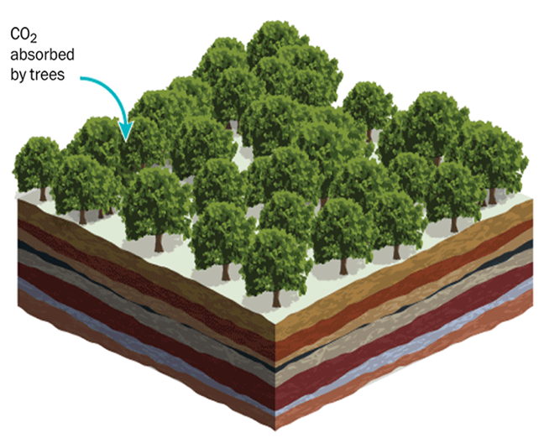*Afforestation and Reforestation* – Both afforestation and reforestation aim to limit the effects of climate change by planting trees. This could take place either where there were no trees before or where forests have been cut down or damaged. As trees grow, they absorb carbon dioxide from the atmosphere and store it for decades or longer, as long as the forest is around. But for this idea to work, we would need a lot of land and water. It is therefore likely to compete with agriculture and other uses. Also, if trees were cut down or happen to burn down, then the carbon dioxide would again be released into the atmosphere.

*Soil Carbon Sequestration* – Soil carbon sequestration aims to limit the effects of climate change by changing agricultural techniques to store more carbon dioxide in soils. This could include planting different crops, leaving crop residues on the field, or increasing the number of trees on agricultural lands. By improving soils and land, it is possible to remove carbon dioxide from the air and store it in soils for decades to centuries. Soil carbon sequestration also requires no additional land and might make soils better for farming. But for this idea to work, we would need farmers and people in other industries to cooperate and take part. Also, if agricultural practices are not sustained, the carbon dioxide would again be released into the atmosphere.

*Marine Biomass and Blue Carbon* – Both marine biomass and blue carbon aim to limit the effects of climate change by improving how much carbon dioxide is stored in the oceans. Blue carbon does this by restoring or growing ecosystems such as mangroves, salt marshes, and seagrass meadows. Marine biomass does this by growing seaweeds or macroalgae. All of these absorb carbon dioxide from the atmosphere as they grow. This can then be stored for decades to centuries at the bottom of the ocean. But for this idea to work, we would need many actors to cooperate and take part.. Also, if ecosystems are disturbed or destroyed or the plants are cut down, the carbon dioxide would again be released into the atmosphere.

*Group 3 (CDR2)*

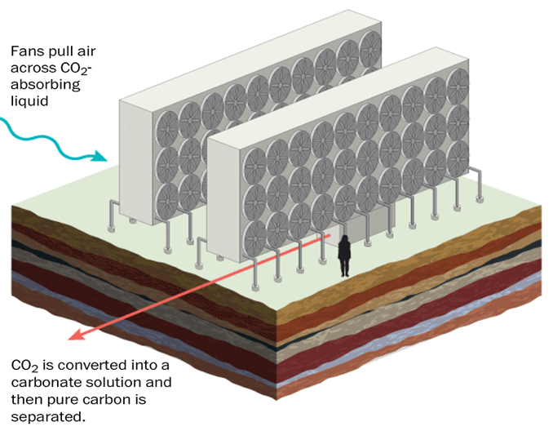*Direct Air Capture with Carbon Storage* – Direct air capture aims to limit the effects of climate change by using very large fans to remove carbon dioxide from the air (direct air capture). Once pulled into the fans, absorptive substances convert the carbon dioxide using a chemical process. It can then be stored indefinitely underground (carbon storage). Direct air capture with carbon storage also needs little land. But for this idea to work, it would require lots of energy along with underground places to store carbon. Direct air capture is also extremely expensive right now and it is not clear if it work at the large scales needed, both of which limit how much it can be used.

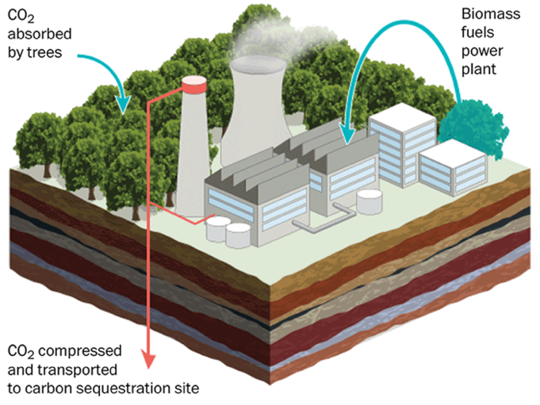*Bioenergy with Carbon Capture and Storage* – Bioenergy with carbon capture and storage aims to limit the effects of climate change by growing and harvesting plants as a source of energy (bioenergy). As plants grow, they absorb carbon dioxide from the air. By burning these plants and chemically capturing the carbon dioxide released, bioenergy can provide energy for homes and businesses or be stored underground indefinitely (carbon capture and storage). But for this idea to work, we would need a lot of land and water (and underground places to store carbon). It is therefore likely to compete with agriculture and other uses. It is also not clear if bioenergy with carbon capture and storage will work at the large scales needed, though some industrial applications do already exist.

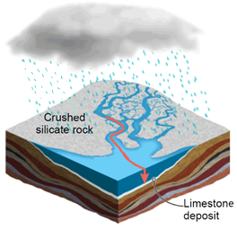*Enhanced Weathering* – Enhanced weathering aims to limit the effects of climate change by increasing the ability of rocks to absorb carbon dioxide from the atmosphere. As rocks such as limestone and basalt are exposed in nature to processes like rain, wind, or the action of waves, they are ground down (weathering), which allows them to absorb carbon dioxide from the air. Since this process takes place extremely slowly, enhanced weathering speeds it up by physically or chemically grinding the rocks before placing them onto soils, beaches, or next to rivers. Over time, rocks and their carbon dioxide are ultimately stored in oceans indefinitely. But for this idea to work, we would need a lot of rocks. This could cause negative ecological and human health impacts (and greater energy use) from additional mining and extraction. Also, it is not clear if enhanced weathering will work at the large scales needed, as only limited trials have been done so far.

*Biochar* – Biochar aims to limit the effects of climate change by heating organic material, such as tree branches and cornstalks, inside a container with no oxygen. This creates black material very similar to charcoal (biochar). If we grind this up and add it to soil, it is possible to remove carbon dioxide from the air and store it in soils for decades to centuries. Biochar might also make better soils for farming. It could also be added to other things, such as concrete, animal feed, or compost. But for this idea to work, we would need farmers and people in other industries to cooperate and take part. We would also need a lot of organic material. Biochar is also quite expensive right now, which limits how much it can be used.